WHEEL AND AXLE

The wheel and axle is made up of two "wheels" that are joined. They act like turning levers.

The wheel and axle can be used to gain a force advantage or a distance (speed) advantage.

For a force advantage - the effort is applied to the edge of the larger wheel.

For a distance advantage - the effort is applied to the smaller wheel.

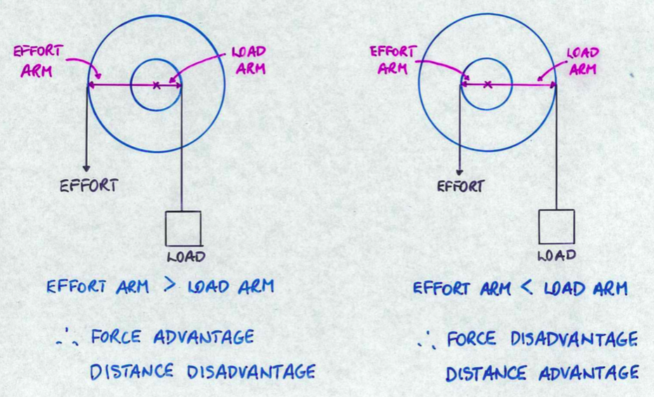

Examples

1. Door knob or handle

Outside turns in a large circle while the axle moves in a much smaller circle.

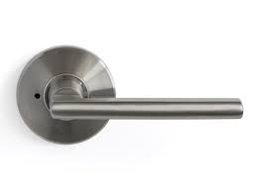
∴ Force advantage
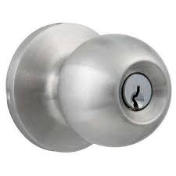

All of the following examples also have a force advantage.

2. Steering wheel
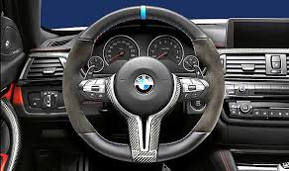

3. Handlebars 4. Spanner 5. Pedals
